

**National University of Computer and Emerging Sciences**

Software Engineering

**“Assignment # 4”**

**E-Learning System**

**STUDENTS NAME AND REGISTRATION NUMBERS:**

Muhammad Umaid Khakwani i19-0666

Hanzla Sibghat i19-0505

Saad Ahmad Jilani i19-0615

**DEGREE PROGRAM:** BS-CS-2019

**SECTION:** D

**SUBJECT NAME:** Software Engineering

**DATE OF SUBMISSION: May 15, 2022**

**SUBMITTED TO:** Dr. Maryam Abdul Ghafoor

__**____________________________________________________________**

# Sprint Backlog:

**Sprint 3: -**

|  |  |  |  |
| --- | --- | --- | --- |
| **User Story** | **Sub-story** | **Tasks** | **Time** |
| 6. | * 1. As a teacher I want to Upload exam so students can attempt it and score grades | 6.10- create a form and upload the exam pdf. | 6.10- 10 hours |
| 23. | 23.1- As a teacher I want to get answers of all students so I can check the correct answers. | 23.10- create a table “exam”.  23.11- answers will be saved in this table  23.12- teachers will get the access of all the answers. | 23.10 2 hours  23.11 1 hour  23.12 2 hours |
| 3. | 3.1- As an admin I want to create a chatbot so users can get help. | 3.11- create a page  3.12- a table is created with predefined questions.  3.13- show predefined questions | 3.11 1 hour  3.12 2 hour  3.13 1 hour |
| 8. | 8.1- As an admin I want to send notifications to all students and teachers and notify them about every change in grade or course. | 8.11 create a table “notification”  8.12- the table will contain the predefined notifications. | 8.11 1 hour  8.12 1 hour |
| 5. | 5.1- As an admin I want to send certificates to all students who have passed the course. | 5.11- the page will be created  5.12- the page will contains the pdf of certificate. |  |

**Roles and Duties for upcoming (Sprint#3)**

|  |  |  |
| --- | --- | --- |
| **Name** | **Role** | **Duty** |
| Saad Jilani | Product Owner | Manage Product and Sprint Backlog, Organize Work, Reporting |
| Umaid Khakwani | Scrum Master | Manage Scrum Process, Enforce Rules, and Remove Blocks |
| Hanzla Sibghat | Scrum Team | Contributed to the creation of user stories |

# Software Testing:

# Sprint 3 Output:

# Trello:

snapshot 1:

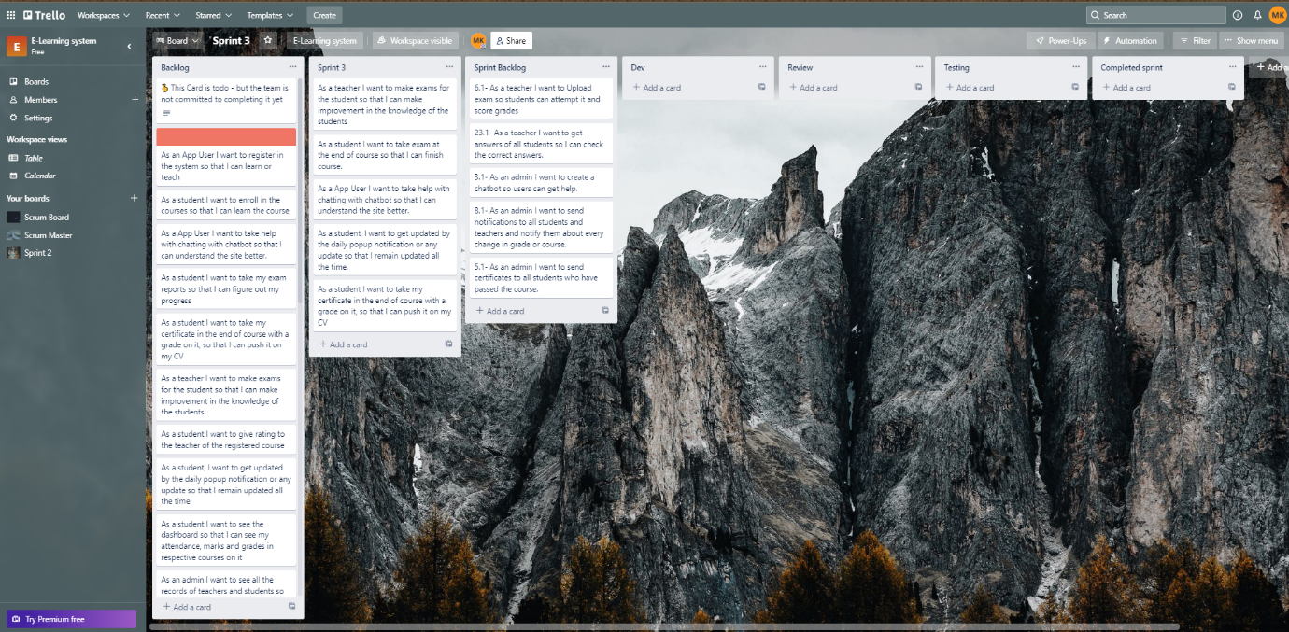

snapshot 2:

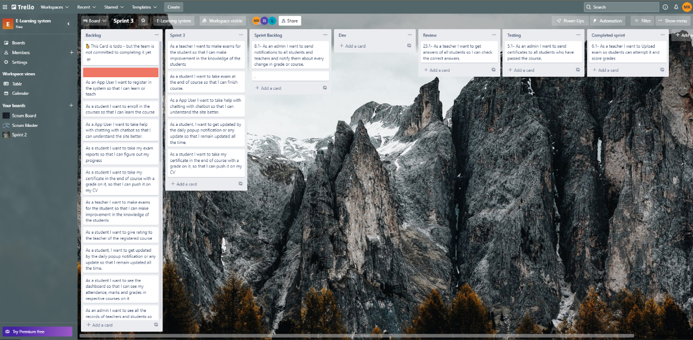

snapshot 3:

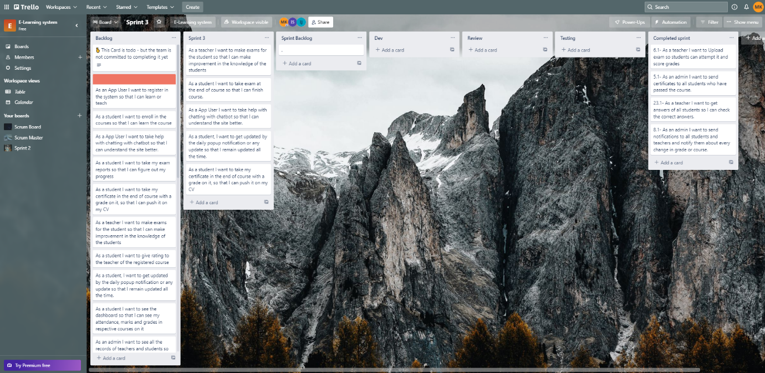

Snapshot 4:

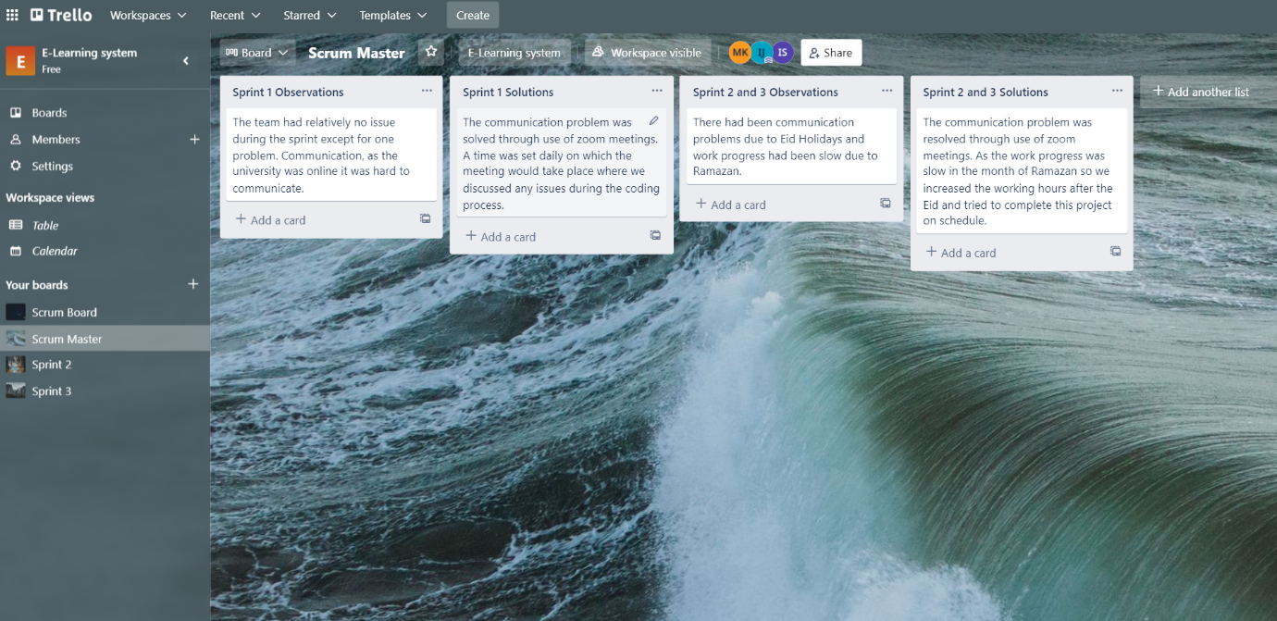

# Burn-Down Chart:

**Burn Down Chart for sprint 2 and 3**

# Gantt Chart: